Structural and Behavioural Model
Community Textile Recovery System
By
Lakshmi Bindu Bandari

1. Use Case Diagram
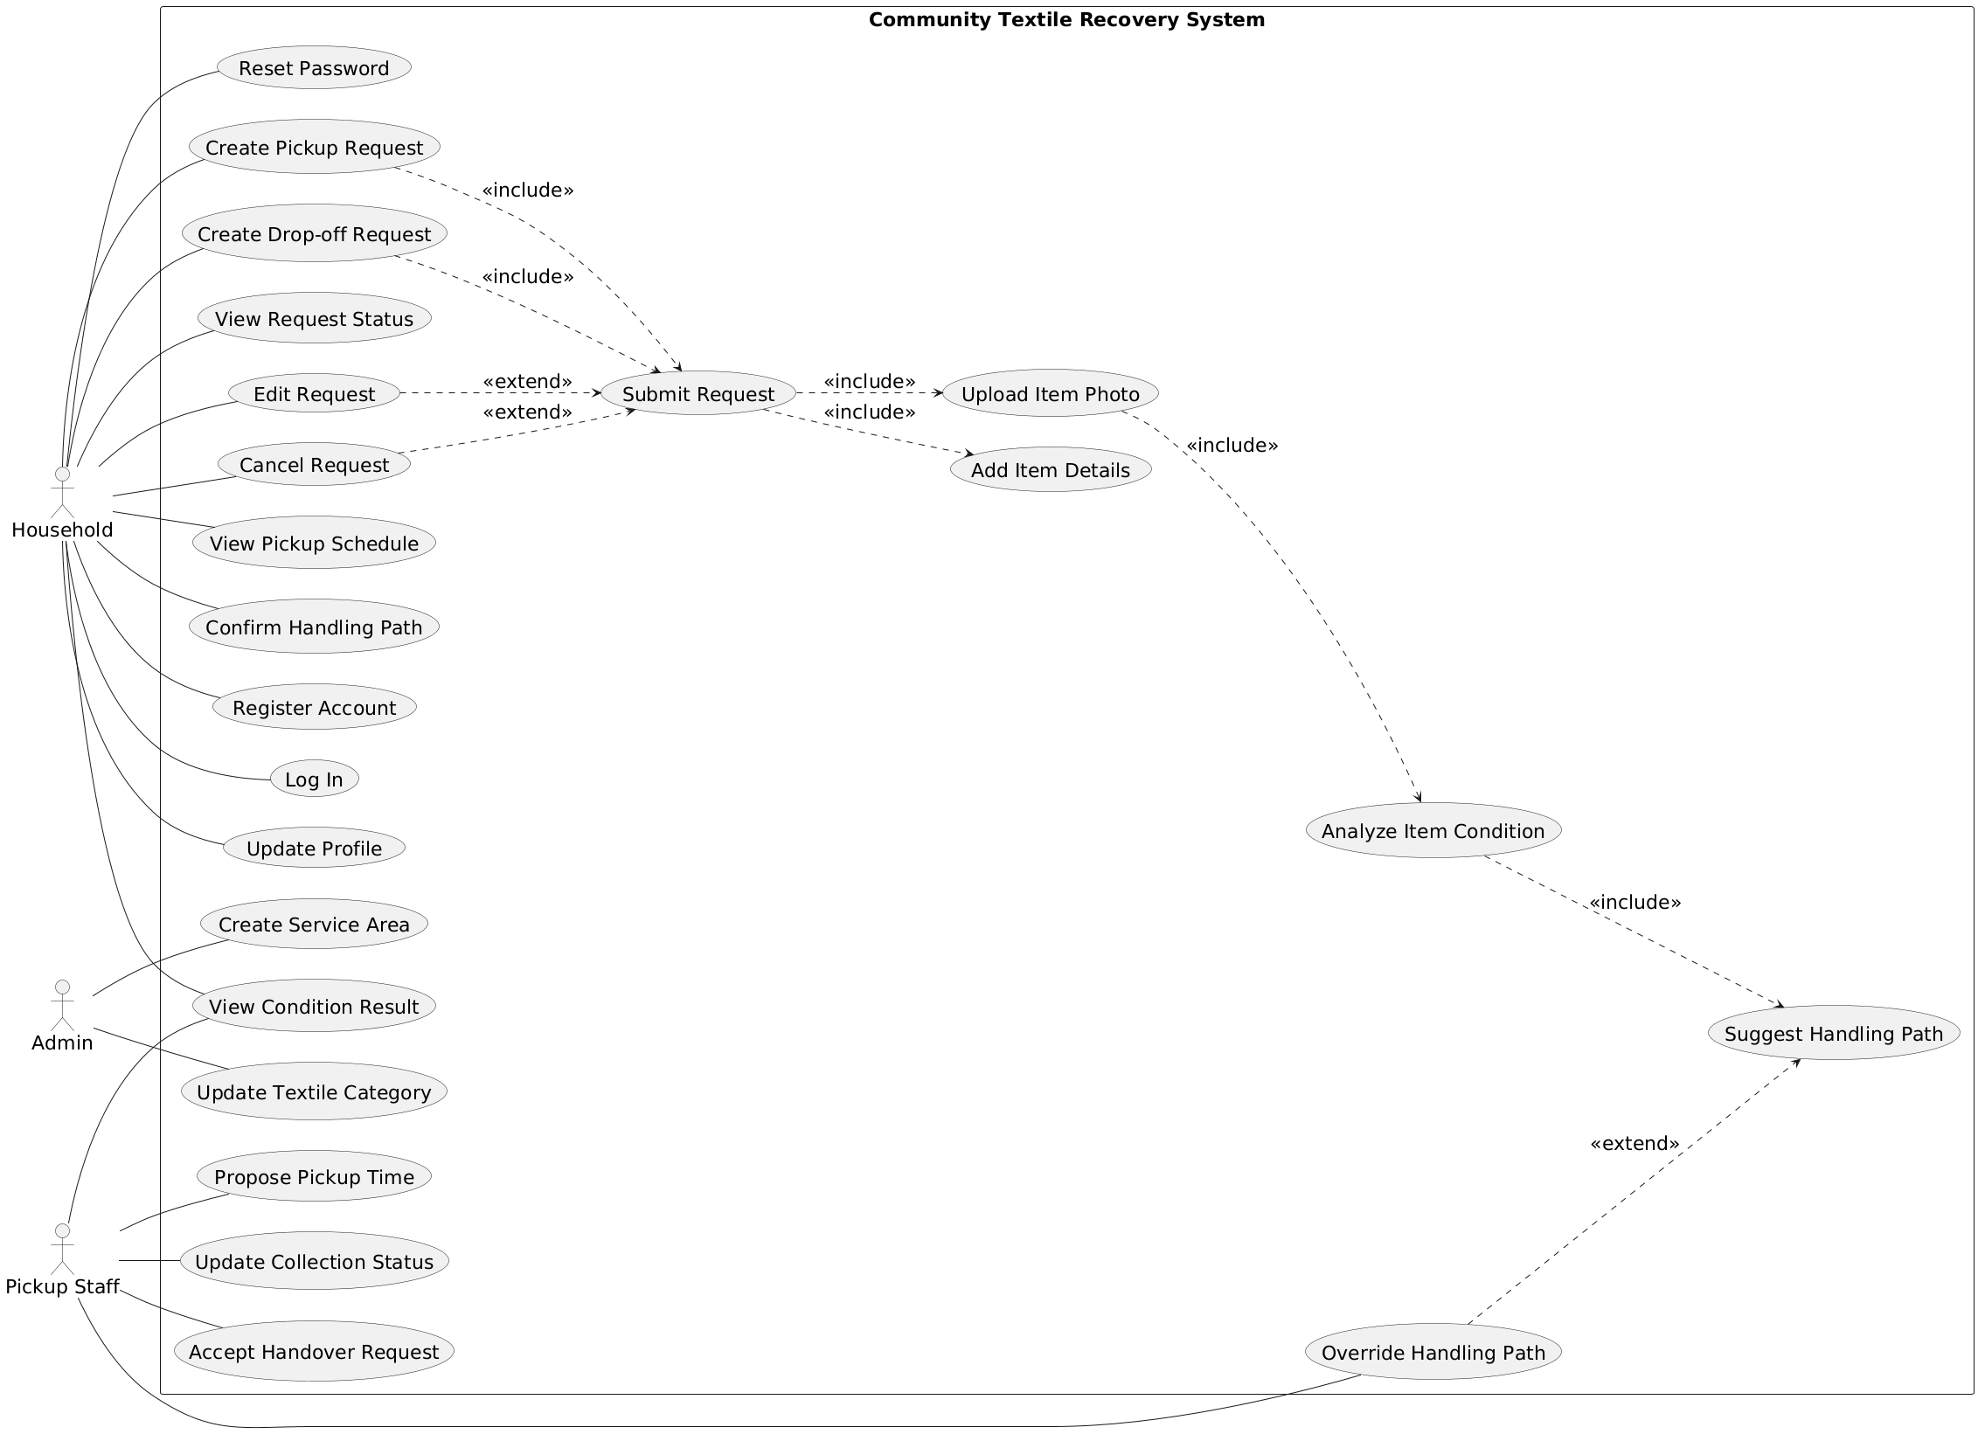
Figure.1 Use Case Diagram

2. Class Diagram
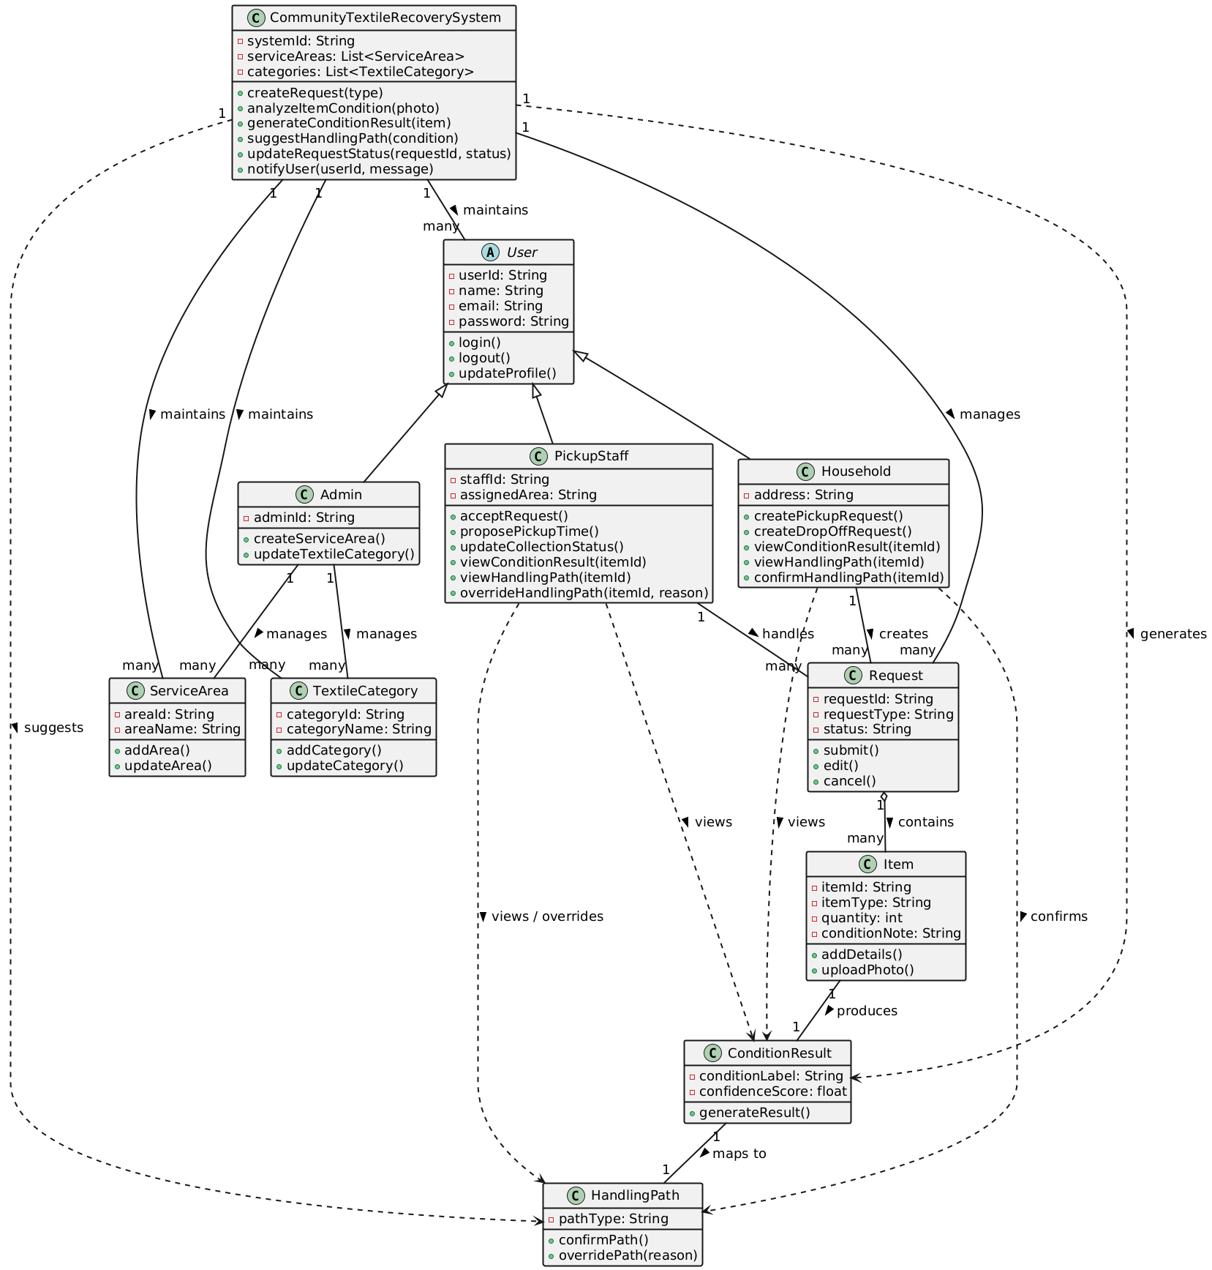
Figure.2 Class Diagram

3. Object Diagram
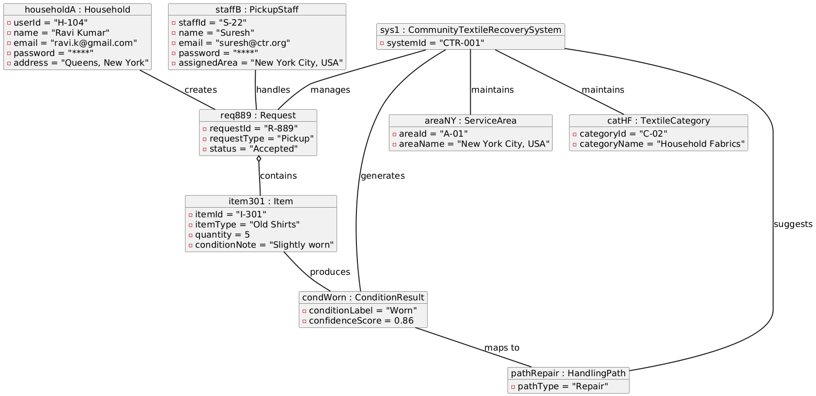
Figure.3 Object Diagram

4. Sequence Diagram
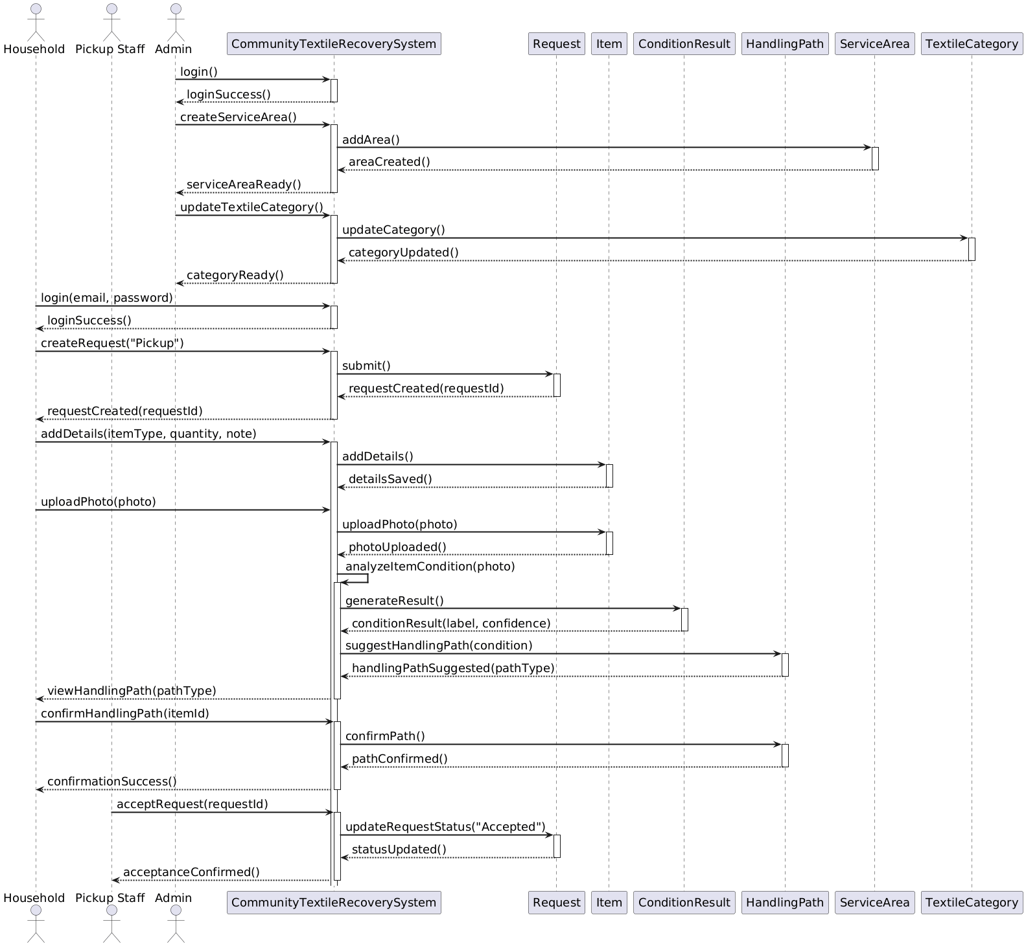
Figure.4 Sequence Diagram

5. Behavioural State Machine Diagram
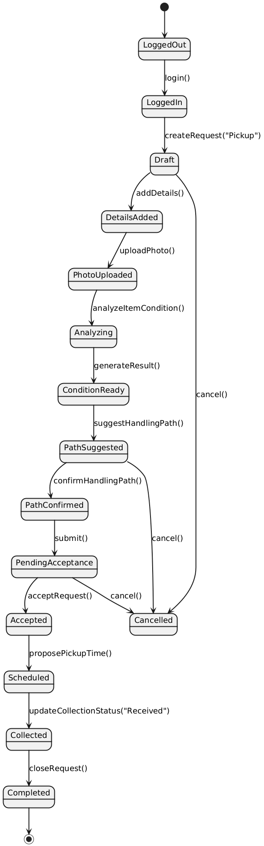
Figure.5 Behavioural State Machine Diagram

6. Mapping: Use cases to structural model and behavioural model
The functional model helped me see what the system should do from the user side. Each use case represents a real task done by a household user, pickup staff, or admin. I went through every use case and noted which parts of the system are involved in doing that task. Based on this, I built the class diagram by placing related actions and data into clear classes like Household, Request, Item, ConditionResult, HandlingPath, and the main CommunityTextileRecoverySystem. Then, I used the same use cases to create the behavioral models. The sequence diagram shows how different objects talk to each other step by step when a pickup request is made, a photo is uploaded, the item condition is checked, and a handling path is chosen. The state machine diagram shows how a request changes from one stage to another until it is completed. This way, every class and interaction comes directly from the approved use cases.
Traceability Table – Use Cases to Classes Mapping
Use Case No. | Use Case Name | Supporting Classes
1 | Register Account | User, Household, CommunityTextileRecoverySystem
2 | Log In | User, Household, PickupStaff, Admin, CommunityTextileRecoverySystem
4 | Update Profile | User, Household, CommunityTextileRecoverySystem
5 | Create Pickup Request | Household, Request, Item, CommunityTextileRecoverySystem
6 | Create Drop-off Request | Household, Request, Item, CommunityTextileRecoverySystem
7 | Submit Request | Request, CommunityTextileRecoverySystem
8 | Add Item Details | Item, Request, CommunityTextileRecoverySystem
9 | Upload Item Photo | Item, CommunityTextileRecoverySystem
10 | Analyze Item Condition | CommunityTextileRecoverySystem, ConditionResult
11 | Suggest Handling Path | CommunityTextileRecoverySystem, HandlingPath
12 | View Request Status | Household, Request, CommunityTextileRecoverySystem
13 | Edit Request | Household, Request, CommunityTextileRecoverySystem
14 | Cancel Request | Household, Request, CommunityTextileRecoverySystem
15 | View Pickup Schedule | Household, Request, CommunityTextileRecoverySystem
16 | Confirm Handling Path | Household, HandlingPath, CommunityTextileRecoverySystem
17 | Accept Handover Request | PickupStaff, Request, CommunityTextileRecoverySystem
18 | Propose Pickup Time | PickupStaff, Request, CommunityTextileRecoverySystem
19 | Update Collection Status | PickupStaff, Request, CommunityTextileRecoverySystem
20 | Override Handling Path | PickupStaff, HandlingPath, CommunityTextileRecoverySystem
21 | Create Service Area | Admin, ServiceArea, CommunityTextileRecoverySystem
22 | Update Textile Category | Admin, TextileCategory, CommunityTextileRecoverySystem
23 | View Condition Result | Household, PickupStaff, ConditionResult, CommunityTextileRecoverySystem

